Self Selected Homework #1
High End Bicycle Frame Manufacturing Methods

Rob McCoy
MEEG453 Manufacturing and Processes

November 13th, 2006

The following is a general overview of the manufacturing methods for performance related bicycles. This does not include mass produced bikes intended for general recreation that are available at many department stores. The bicycles that are going to be discussed are produced for cycling enthusiast as well as amature and professional athletes in the sport. Due to the vast variation of both bikes themselves and the construction methods, this article will only include bikes intended for road cycling. The article will cover manufacturing economics, engineering relevance for young engineers, basic components, and the variation of construction methods based on materials selection for the frame.
Introduction to Bicycle Frames

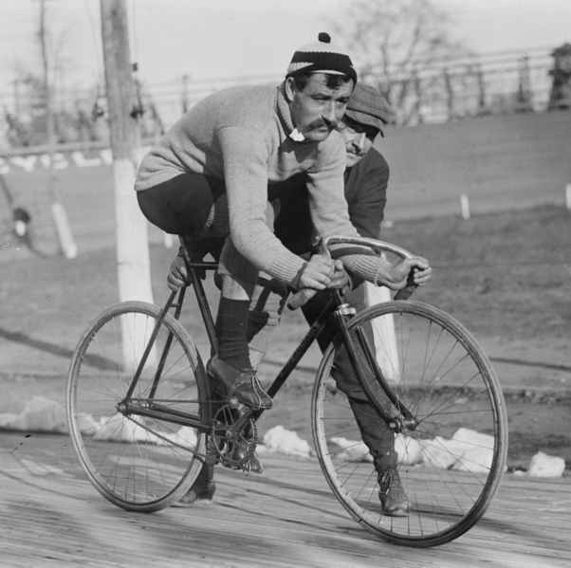
The bicycle has now gone through almost two centuries of evolution to arrive at the specialized design now used for road cycling. Despite the time passed, not too much has truly changed in the appearance and style of the frame itself, especially in the last 100 years. Although radical designs have attempted to claim better performance benefits, the traditional ‘double triangle’ design is still the main design today. Making up the ‘double triangle’ shape are 6 pieces of tubing. Numbered in the image below, #1 is the Head Tube which receives the fork steerer. #2 is the Down Tube, #3 is the Top Tube, #4 is the Seat Tube, #5 is the Chain Stays and #6 is referred to as the Seat Stays. The bottom bracket shell (#7) is the short hollow tube that houses the bearings and axel for the cranks.
c.1909

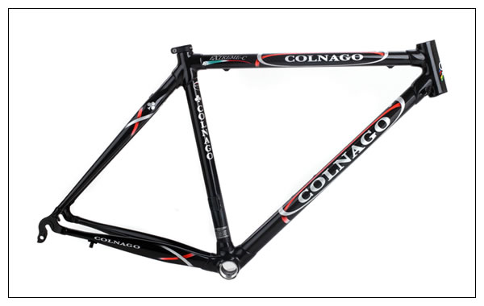
Although the general frame geometry has undergone only relative minor changes, the materials and construction methods have changed drastically with newer material technology introduced within the last 25 years. The bicycle frame has become a highly engineered appliance, especially with the growth of competitive cycling. Major factors/characteristics can now be determined and tuned with material selection, construction methods and construction geometry. Some of these factors include weight, stiffness, vertical compliance “ride quality” and steering character. And, one factor that can never be discounted is the appearance of the finish of the frame.
1
2
3
4
5
6
7

Materials Lead to Methods

1. Steel
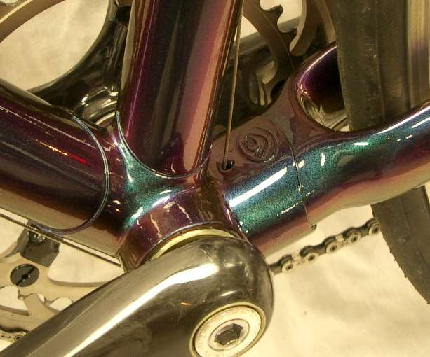
Steel was the long standing traditional framing material up until the early nineties. It is still widely used today in high end frames both for racing and enthusiast applications. The conventional technique for steel frame fabrication is ‘lugged’ construction which involves oversized and thicker joining pieces of steel at tube junctions (for example: where #3, 4 and 6 meet in the above figure.) The smaller diameter steel tubes are slid into the larger diameter mates of the casted lugs and then joined by brazing which avoids high temperatures that could change the grain structure of the steel at the critical connections. The tubes are very thin and care has to be taken not to weaken the strength during manufacturing. Developments in steel processing technology, such as air hardening, have allowed steel frames to be now joined by TIG or MIG welding processes as well. These methods, especially TIG welding, are require less labor (more economic) and have become the strong majority method in steel frame joining turning brazed lugged construction into a niche and generally hand built option. Welding, however, requires precisely cut tube ends to receive the profile of adjoining tube which adds complication but reduces excess material (and excess weight.)
Steel Lugged Construction at the Bottom Bracket

The steel used in high end bicycles are generally high strength alloys such as chromoly which allows for thinner tube walls and hence lighter frame weights which is important for competitive applications. Steel frames, although heavier than their aluminum or composite counterparts, are known for their excellent ride characteristics in ‘smoothing’ the road to some degree by damping vibration and providing slight vertical compliance.

2. Aluminum
Aluminum has overtaken steel in the last 15 years mainly because of its higher specific strength, easy processing and resistance to weather corrosion. The weight vs. stiffness ratio has become the major design factor for competitive frames and aluminum’s characteristics allow for greater optimization over high strength steel alloys. Aluminum frames are usually TIG welded however more exotic methods are sometimes employed. The best example is the major US manufacture, Trek, who uses a bonding agent to join the tubes together.
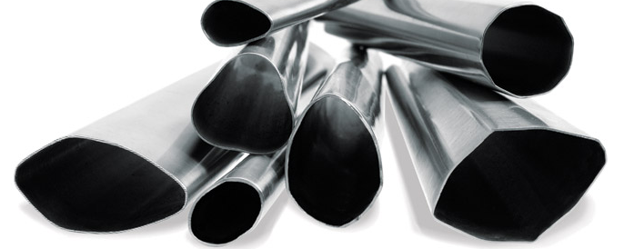
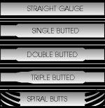
One of the largest benefits to aluminum is the ability to shape the tubing. Almost all competitive frames now use oversized large diameter tubing when employing aluminum to create a stiffer frame for better power transfer from the cranks to the rear wheel. Besides oversized tubing, hydroformed tubes are used on most high end frames. These alternate shapes are usually claimed to provide greater stiffness in critical planes of motion and almost always add aesthetic appeal no matter their structural effectiveness. Stunning effects can be created by this process that can’t be created with steel tubing. Also on the topic of frame shaping is the idea of butting. Butting is tapering the thickness of the walls of the tubing to optimize thickness to where stresses are located. A butted tube is generally thinner at the ends where bending stresses are minimal. Internal butting up to three (“triple butted”) is a common practice for all tubing materials to reduce the weight of the frame.
Hydroformed Aluminum Tubing

Aluminum’s downfalls are that since it does not have a defined fatigue limit, an overworked aluminum frame will fail at some point into its life. Aluminum frame’s higher stiffness also translates into less vertical compliance and a rougher ride. The usual alloys used are high strength 7 series and Scandium to provide a lightweight frame.

3. Titanium

Titanium has become one of the most highly regarded frame materials for high end applications. Although more attuned to enthusiast rather than racing, titanium’s stiffness to weight ratio is about the same as steel but it holds a key characteristic over aluminum and steel both. The elongation before failure is important for frame life over time as well as a higher factor of safety for niche market frame builders who don’t fully engineer their designs. Of course corrosion resistance is another added benefit and titanium frames are often left unpainted. The main key to titanium is that it is expensive which makes most buyers believe that this is an indication to better performance. In fact, the percentage of professional racers who use titanium frames is miniscule. It is also difficult to machine and requires careful TIG welding which increase manufacturing cost.

Even though less expensive alloys are used such as 3/2.5 are used, the cost of titanium frames keep them mostly to enthusiasts who are looking for exclusive frames that display their buying power.

4. Carbon Fiber
Composite construction has turned the competitive bicycle frame industry upside down. Frame weights using carbon fiber has shattered a long standing 1kg minimum frame weight limit and pressed stiffness vs. weight ratios to a new extreme. The lightest composite frames are now in the area of 800 grams while a light aluminum frame is in the area of 1300g and steel approaching 1500g. This is mostly due to advancing materials such as carbon nanotube impregnated resin as well as advanced lay up techniques that allow tube thicknesses to be precisely controlled for areas of critical stress. In the last year, almost every high end composite race frame has switched to a carbon nanotube resin for increased stiffness of the composite matrix. Tube shapes have gone to the extreme, especially in high stress areas such as the bottom bracket area which receives high torsional stress. Higher stress fibers such as boron are also added to points of high stress to increase stiffness.
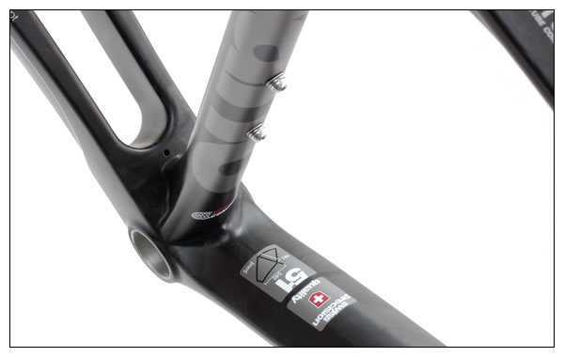
Two distinct manufacturing methods are used to assemble carbon fiber frames. The first method is lugged construction similar to that of steel. In the case of a composite frame, however, the lugs are usually made from either aluminum or carbon fiber with titanium also used in rare cases rather than steel. The carbon tubes are then bonded to the lugs to complete the fabrication.
Massive reinforcement at the Bottom Bracket of a composite frame with carbon nanotube resin
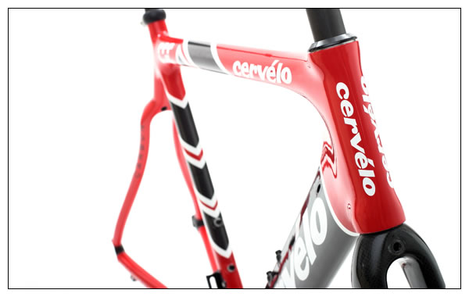
The second method is to eliminate the lugs all together and create a single monocoque structure with all tubes joined together in one lay up process. This is a much more expensive method as it requires completely manual construction and it reserved for the most expensive and exclusive frames. Structurally, however, the benefit of no joints heightens the level of stiffness even further provided a slight advantage in performance. Less material overlap is used as well and the frames can be made even lighter. Despite the performance gains, the control of the process is difficult and filler materials are sometimes required to keep the void space of the inside of the tubes supported during construction which further complicates the process of hand laid monocoque construction.
An example of unique shaping to create an aerodynamic frontal profile

Aside from the performance gains of carbon fiber, it is also highly regarded for its road smoothing abilities. Because of this, it is often used in critical areas with other frame materials with harsher ride characteristics, such as aluminum frames, to dampen road vibrations.

5. Magnesium
Although magnesium seems like an ideal material for bicycle frames on paper due to the excellent specific strength and damping properties, the difficulty in possessing as well as extremely poor corrosion properties prevent it from becoming mainstream. Some companies do, however, produce magnesium frames and include generous applications of surface treatments (paint) to help prevent corrosion.

Economics

As with most consumer products, the economics of bicycle frames is a major contribution to the manufacturing methods, quality and materials used. Two distinct markets are targeted; high volume mass production and low volume custom fabrication.

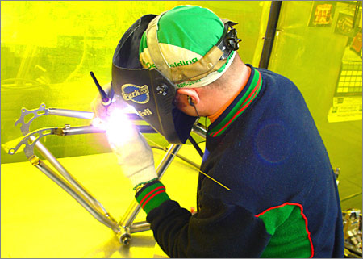
The mass production market has changed drastically over the last few years as more and more frames are being contract manufactured in South East Asia. Most of the larger brands own Taiwanese factories but medium volume companies use common suppliers with great results in quality and performance as well as value. For an industry that relies heavily on human labor for composite lay up, metal machining and welding, a low cost labor environment is ideal. Eventually the Asian craftsman develop their skills to a level that is equal to or superior to that of traditional frame builders in America or Europe and the quality of the frames are excellent despite the lower labor cost. Despite this general equalization of quality, many high end frames are still built in America and especially Europe by craftsman. These frames are more expensive because of this and are usually held in a higher status. For reference, the professional riders in Europe ride about 50% Asian produced bikes and 50% European built bikes which shows that there generally is an equalization in quality.

The custom built niche market is strong in America and Western Europe where customers have the money to spend on frames built to their body’s specific dimensions. Due to lower part quantities, the cost of these frames are generally freighting high. A custom carbon frame can’t be had for much less than $5000 and custom titanium is usually in the ballpark of $3000. The construction of these frames is usually easier methods with more room for builder error such as lugging however experienced builders will use TIG welding for custom steel or titanium frames. They are usually constructed by one person and it is held in a jig for brazing or welding. No assembly lines means that more specific attention to that particular frame but the efficiency of the system is drastically reduced and not a goal. Custom frames are jewels to cycling enthusiast rather than appliances and the price reflects this.
A custom builder TIG welding a Titanium Frame

To a Young/Mature Engineer
Almost everyone has ridden a bicycle at some point in their life. Bicycles are a great way for engineers to relate technical knowledge into a practical application that is simple to relate to. The major significance of this topic for a beginning engineer is the application of common engineering principles that can easily related to for a familiar application. The major significance of this topic for a mature engineer is the critical performance values that high end bikes exhibit such as strength vs. weight rations, vibration damping properties and low factors of safety which lead to a high demand of the designer’s attention to the engineering.

Learning

From the article, I have learn the many different manufacturing and processing techniques of bicycles, but more broadly, structural materials as whole. It is apparent that different materials have different properties which must be accounted for when joining/assembling as a whole system which must perform to a high level. Also different ‘customers’ have different metrics in what they are looking for in a bicycle frame which must be accounted for in process selection on the condition of value, performance and exclusivity. Personally, the research for this article will be very helpful when I decide to buy a bicycle frame and what characteristics I want to frame to exhibit.

References

“Metallurgy for Cyclist by Scot Knowl.” http://spokesmanbicycles.com/page.cfm?PageID=328 November 12th, 2006

“Trek Factory Tour” http://www.chainreaction.com/trekfactory.htm November 12th, 2006

"Bicycle frame." Wikipedia, The Free Encyclopedia. 9 Nov 2006, 20:26 UTC. Wikimedia Foundation, Inc. 12 Nov 2006 http://en.wikipedia.org/w/index.php?title=Bicycle_frame&oldid=86786285

“Seven Factory Tour” Cyclingnews.com 15 December 2005.
http://www.cyclingnews.com/tech.php?id=tech/2005/features/seven_factory

3rd Annual North American Hand Made Bike Show http://www.handmadebicycleshow.com/

Video

Eddy Merckx Factory Tour (Belgium) (8:08) wm.vitalstreamcdn.com/worldcycling_vitalstream_com/Eddy-Final.wmv
Ridley Factory Tour (Belgium) (1:27)
wm.vitalstreamcdn.com/worldcycling_vitalstream_com/RidleyTour.wmv

